W.S # 2: Integers Math 7 / 40
1
2
3
4
5
6
7
8
9
10
11
12
13
14
15
16
17
18
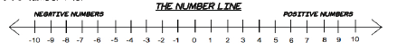
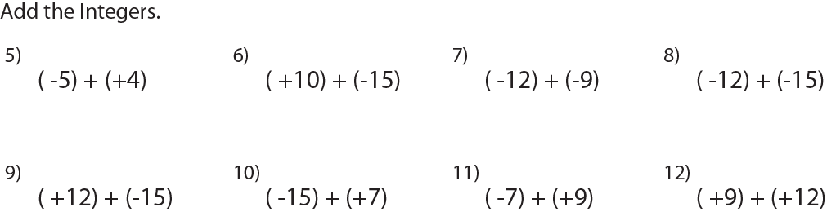
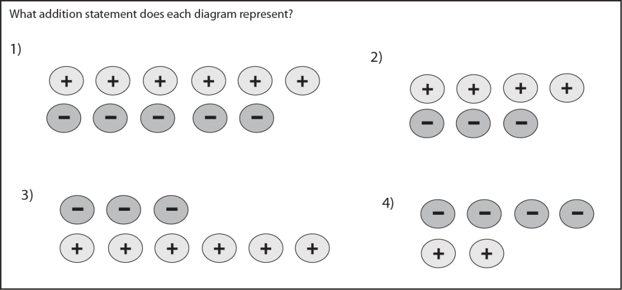

13) The temperature in Resolute, Nunavut, one afternoon in May was
- 8˚C. The temperature decreased by 6˚C to reach the overnight low temperature. What was the overnight low temperature?

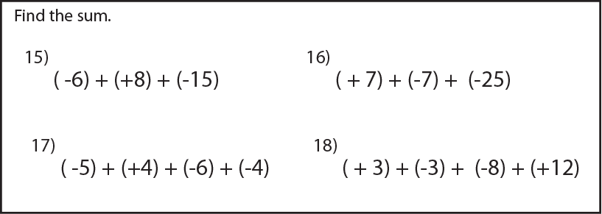
14) The most rapid temperature increase by a chinook took place in Spearfish, South Dakota. One January morning, the temperature was
-20˚C. The temperature then increased by 27˚C in two minutes. The temperature continued to climb another 5˚C before stopping. It then dropped by 32˚C in 27 minutes. What was the final temperature?

19
20
21
22
23
24
25
26
27
28
29
30
31
32
33
34
35
36
37
38
39
40
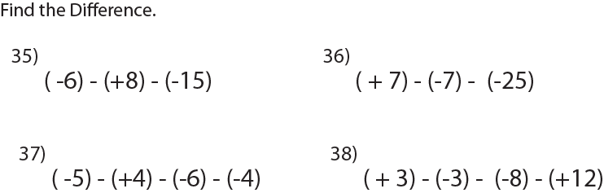
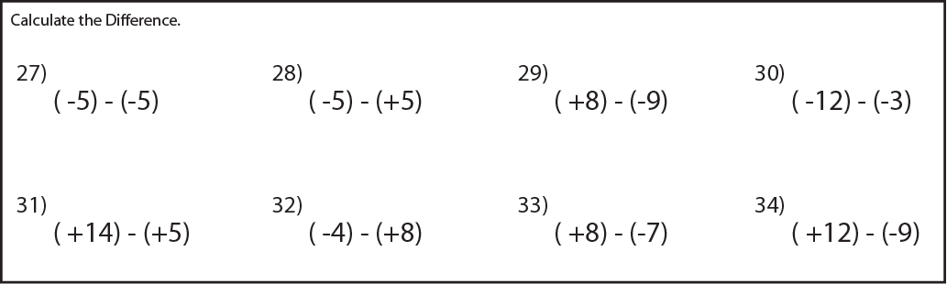
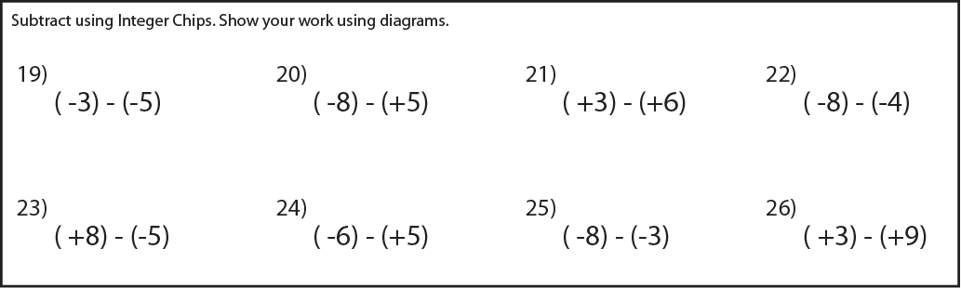

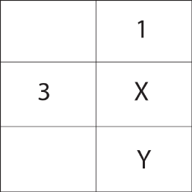
39) Bonus 1: In the table shown, the numbers 1, 2, and 3 are placed so that each number occurs only once in each row and only once in each column. What is the value of X + Y?

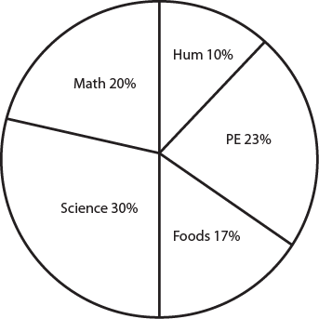
40) At Mt. Slesse Middle School , a total of 480 students voted for their favourite subject. The results are summarized in the pie chart. How many students voted for math?

W.S # 2: Integers Math 7
1 | (+6) + (-5)
2 | (+4) + (-3)
3 | (-3) + (+6)
4 | (-4) + (+2)
5 | -1
6 | -5
7 | -21
8 | -27
9 | -3
10 | -8
11 | 2
12 | 21
13 | -14˚C
14 | -20˚C
15 | -13
16 | -25
17 | -11
18 | 4
Name: _______key_________________________ /38

13) The temperature in Resolute, Nunavut, one afternoon in May was
- 8˚C. The temperature decreased by 6˚C to reach the overnight low temperature. What was the overnight low temperature?

14) The most rapid temperature increase by a chinook took place in Spearfish, South Dakota. One January morning, the temperature was
-20˚C. The temperature then increased by 27˚C in two minutes. The temperature continued to climb another 5˚C before stopping. It then dropped by 32˚C in 27 minutes. What was the final temperature?

19 | 2
20 | -13
21 | -3
22 | -4
23 | 13
24 | -11
25 | -5
26 | -6
27 | 0
28 | -10
29 | 17
30 | -9
31 | 9
32 | -12
33 | 15
34 | 21
35 | 1
36 | 39
37 | 1
38 | -2
39 | 5
40 | 96

39) Bonus 1: In the table shown, the numbers 1, 2, and 3 are placed so that each number occurs only once in each row and only once in each column. What is the value of X + Y?

40) At Mt. Slesse Middle School , a total of 480 students voted for their favourite subject. The results are summarized in the pie chart. How many students voted for math?

