W.S # 1: Integers Math 7
1
2
3
4
5
6
7
8
9
10
11
12
13
14
15
16
Name: ________________________________ /33
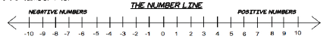
Term | Matching Example
- Zero Pair  - Positive Integer Chip  - Negative Integer Chip  - Diagram of a Zero Pair | a.  b. A pair of integer chips with one positive chip and one negative chip.  c.  d.

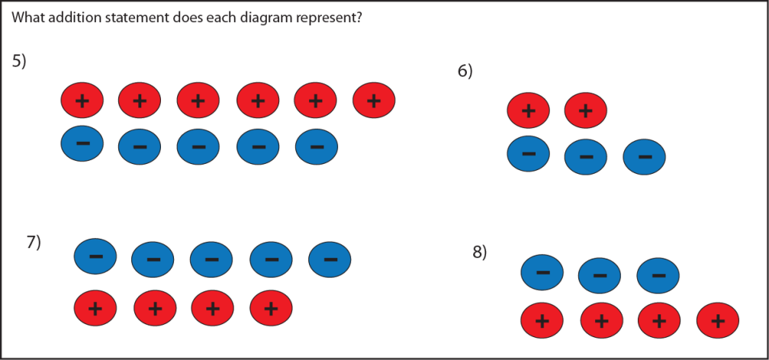

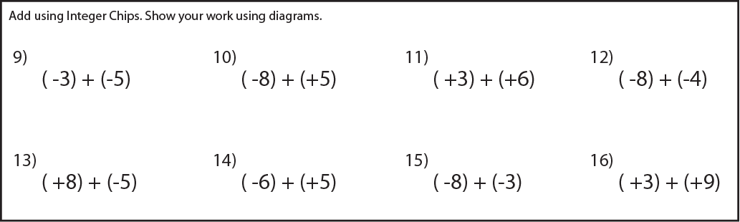

17
18
19
20
21
22
23
24
25
26
27
28
29
30
31
32
33
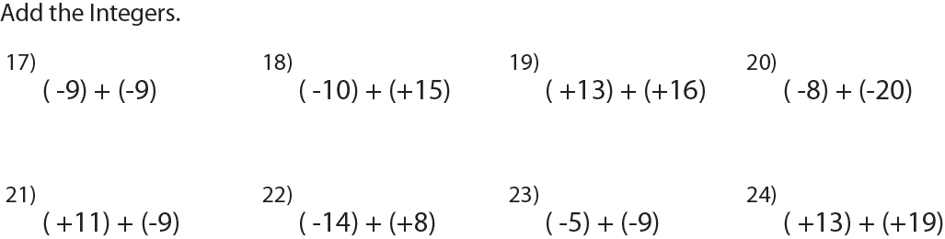

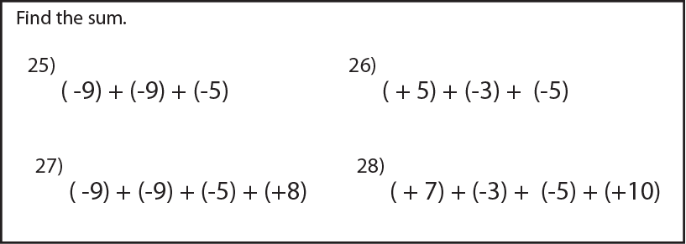

Use the sum of two integers to represent each situation.

29) Sharon found $25 and then spent $18. How much does she have left?

30) A tree frog climbed up a tree 35 meters and then jumped onto a branch 6 meters below its current height. How high is the tree frog from its original position?

31) In one football game the chiefs scored 38 points and the seahawks scored 56 points. By how many points did the seahawks win the game?

32) A wright whale dove 100 meters to hunt for squid and then dove another 50 meters in pursuit of a squid. What was the wright whales final depth?

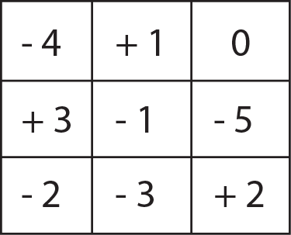
33) In this magic square the sum of each diagonal, row, and column results in the same answer. What is the magic number for this square?

W.S # 1: Integers Math 7
1 | B
2 | A
3 | D
4 | C
5 | (+6) + (-5)
6 | (+2) + (-3)
7 | (-5) + (+4)
8 | (-3) + (+4)
9 | -8
10 | -3
11 | 9
12 | -12
13 | 3
14 | -1
15 | -11
16 | 12
Name: ___________KEY_____________________ /33

Term | Matching Example
- Zero Pair  - Positive Integer Chip  - Negative Integer Chip  - Diagram of a Zero Pair | a.  b. A pair of integer chips with one positive chip and one negative chip.  c.  d.

17 | -18
18 | 5
19 | 29
20 | -28
21 | 2
22 | -6
23 | -14
24 | 32
25 | -23
26 | -3
27 | -15
28 | 9
29 | (+25) + (-18) = 7
30 | (+35) + (-6) = 29m
31 | (-38) + (+56) = 18pt
32 | (+100) + (+50) = 150m
33 | -3

Use the sum of two integers to represent each situation.

29) Sharon found $25 and then spent $18. How much does she have left?

30) A tree frog climbed up a tree 35 meters and then jumped onto a branch 6 meters below its current height. How high is the tree frog from its original position?

31) In one football game the chiefs scored 38 points and the seahawks scored 56 points. By how many points did the seahawks win the game?

32) A wright whale dove 100 meters to hunt for squid and then dove another 50 meters in pursuit of a squid. What was the wright whales final depth?

33) In this magic square the sum of each diagonal, row, and column results in the same answer. What is the magic number for this square?

