MATH WORD PROBLEM SOLVING BOOKLET
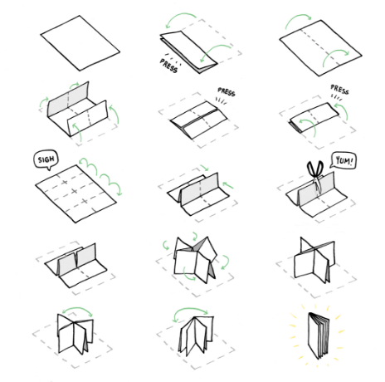
STEP 1 – BLANK 8 ½ X 17 INCH PAPER
STEP 2 – FOLD THE PAPER AS SHOWN TO THE RIGHT. YOU WILL NEED SCICCORS FOR A SMALL CUT
STEP 3 – COMPLETE THE FOLLOWING 6 WORD PROBLEMS IN YOUR Create an 8- page mini-book.
Page 1 – Cover…. Illustrate how we see or use integers in everyday life.
Page 2 – Text Pg. 314 #10
Page 3 – Text Pg. 320 #9
Page 4 – Text Pg. 320 #12
Page 5 – Text Pg. 321 #14
Page 6 – Text Pg. 329 #14
Page 7- Text Pg. 329 #20
Page 8 – Back cover….. write your own problem that requires the solver to add/subtract integers. To extend means you are able to create and solve a multi-step problem. Solve the problem on a separate sheet of paper.

STEP 4 – SPLIT EACH PAGE INTO THREE PARTS – WRITE THE PROBLEM NUMBER AND PAGE IN THE TOP RIGHT CORNER
P - PICTURE – draw an image of the problem (1 marks)
M - MATH – show your calculations and solve (2 marks)
A - ANSWER & CHECK - include required units… $, cm, kg (1 marks)

STEP 5 – TITLE PAGE AND LAST PAGE OF THE BOOKLET
PICTURE IS YOUR TITLE PAGE (make it colorful + include title and your name)
BACK PAGE - write your own problem that requires the solver to add/subtract decimals. To extend means you are able to create and solve a multi-step problem. Solve the problem on a separate sheet of paper.
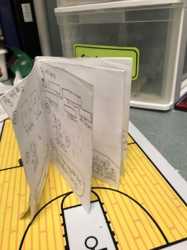
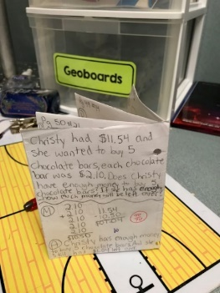
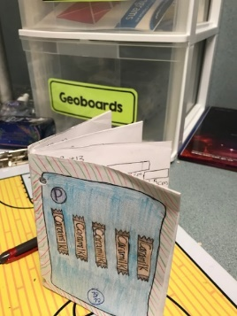

BE SURE TO PUT YOUR NAME ON THE FRONT AS WELL AS THE TITLE OF YOUR BOOKLET

